# Table of content

1. Main
2. Progress
3. Design
4. Documentation (Summary)
5. HTML and CSS code

# Main

Volodymyr Pavlovskyi 300283178

Title: The #SkyBikes extreme biketrial team web-site.

First page: Main Welcome page with an invitation to the website (Welcome to #SkyBikes). Links to other pages of web site placed at the top of Welcome, Multimedia, About and Contacts pages. The background is video. The navigation bar at the right top of the page with links to other pages will disappear while scrolling down.

Second page: Multimedia. Here are multimedia such as videos about extreme sports and team.

Third page: About. Page with a description of the team and some contact information.

No group, only one developer.

Fourth page: Contacts. Here are contacts on Facebook, Instagram, Gmail and VK accounts of the team. Also here is placed form for contact, which user should fill.

# Progress

October 1. Main idea and purpose of the site were created together with probable appearance. Decided how many parts site will have and what information will be represented. Also, some ideas about appearance and look were developed (will represent with links to external resources like YouTube and Vimeo). HTML and CSS files of the Welcome page were created via WebStorm editor.

October 7. Background and some style on the Welcome page were created. Decided to use grids for formatting page and some materials were read about them. Also, buttons at navigation bar and additional style things were created and added to the Welcome page.

October 8. Final appearance of the Welcome page was created in Photoshop, such as a position of elements and background settings. Some of the elements were realized in HTML and CSS files. Also, the design of other three pages was developed and type of elements which contains at this pages was approved. Some changes to the Welcome page have been applied (opacity of background video and type of fonts). The Background color of buttons in navigation bar was changed to black when hover and transparent when click.

October 22.

Some changes were applied to the Main page, which changes the name to Welcome. Picture with text “Welcome to #SkyBikes” was created in Photoshop. Also changed background video (delete audio and make shorter to prevent long loading). Decided to make page static and simple without any useless information. Changing buttons position from right top to center in progress, but still not sure about that. Some additional information about <div> elements was read.

October 28.

First prototype of About page was created. After few hours, About page contains 3 photo and 3 paragraphs of text. Contacts are symbols of Gmail, Instagram, Facebook and VK. User can go to connected pages by clicking the symbol. When user hover the symbol, css creates 1px border around symbol for better vision effect. Also, to the end of About page was added text (#SkyBikes © All rights reserved). Background now is static picture.

November 5.

Some changes were applied to Welcome and About Pages after watching tutorials on YouTube. Added new css for better-looking. Found and solve the problem with video size and stretch. Also, the changed grid of both pages created new divs instead of old, which were not very good. Change the background of About page to the same video as in Welcome page, and cover most of it with black div, which contain information (photos, text, and links). Will change background later.

New images of both pages below in upgraded Layout Design.

November 12.

Create Multimedia page. Decide to paste only #SkyBikes team videos on this page without any photos and music. Each video is placed on separate div for the better look. The page is pretty simple, with background purple color. Also, some minor changes applied to about page (added footer and change background)

November 19.

Decided to change Riders page to Contacts page with information. On this page, the user can click the logo on Instagram, Facebook, VK and Gmail and move to #SkyBikes team pages on these websites. Also, create 3 forms for call or text back. Forms are “Name”, “E-mail” and “Phone number”. Using these forms, the user can leave his information and manager of the team will call or text back in few hours. All forms contain separate css and javascript file. The background is a picture. Also added the border for better-looking.

November 26.

Some changes to all projects were applied. Changed video in Welcome page for smaller to prevent internet traffic usage. In Multimedia page change video sources to YouTube videos. Also, make all videos same size. In About page change one div to describe prices instead of contacts, which appears now on the separate page. In Contacts page change background and fonts. Also, buttons contain new font because the previous one did not work on Chrome. Navigation buttons order changed to be more logical. Also, decided to create separate css file for buttons and just add this file to every page instead of adding full buttons style code in every page css file. Add font from https://fonts.googleapis.com to every page. Overall, make pages code more clear and understandable, delete all comments and unused properties. Change all titles to present contained data. Also, add some parameters for preventing selecting text on buttons.

# Design

Updated November 26.

The web-site contain four pages: Welcome page, Multimedia page, Contacts page and About page.

Welcome page

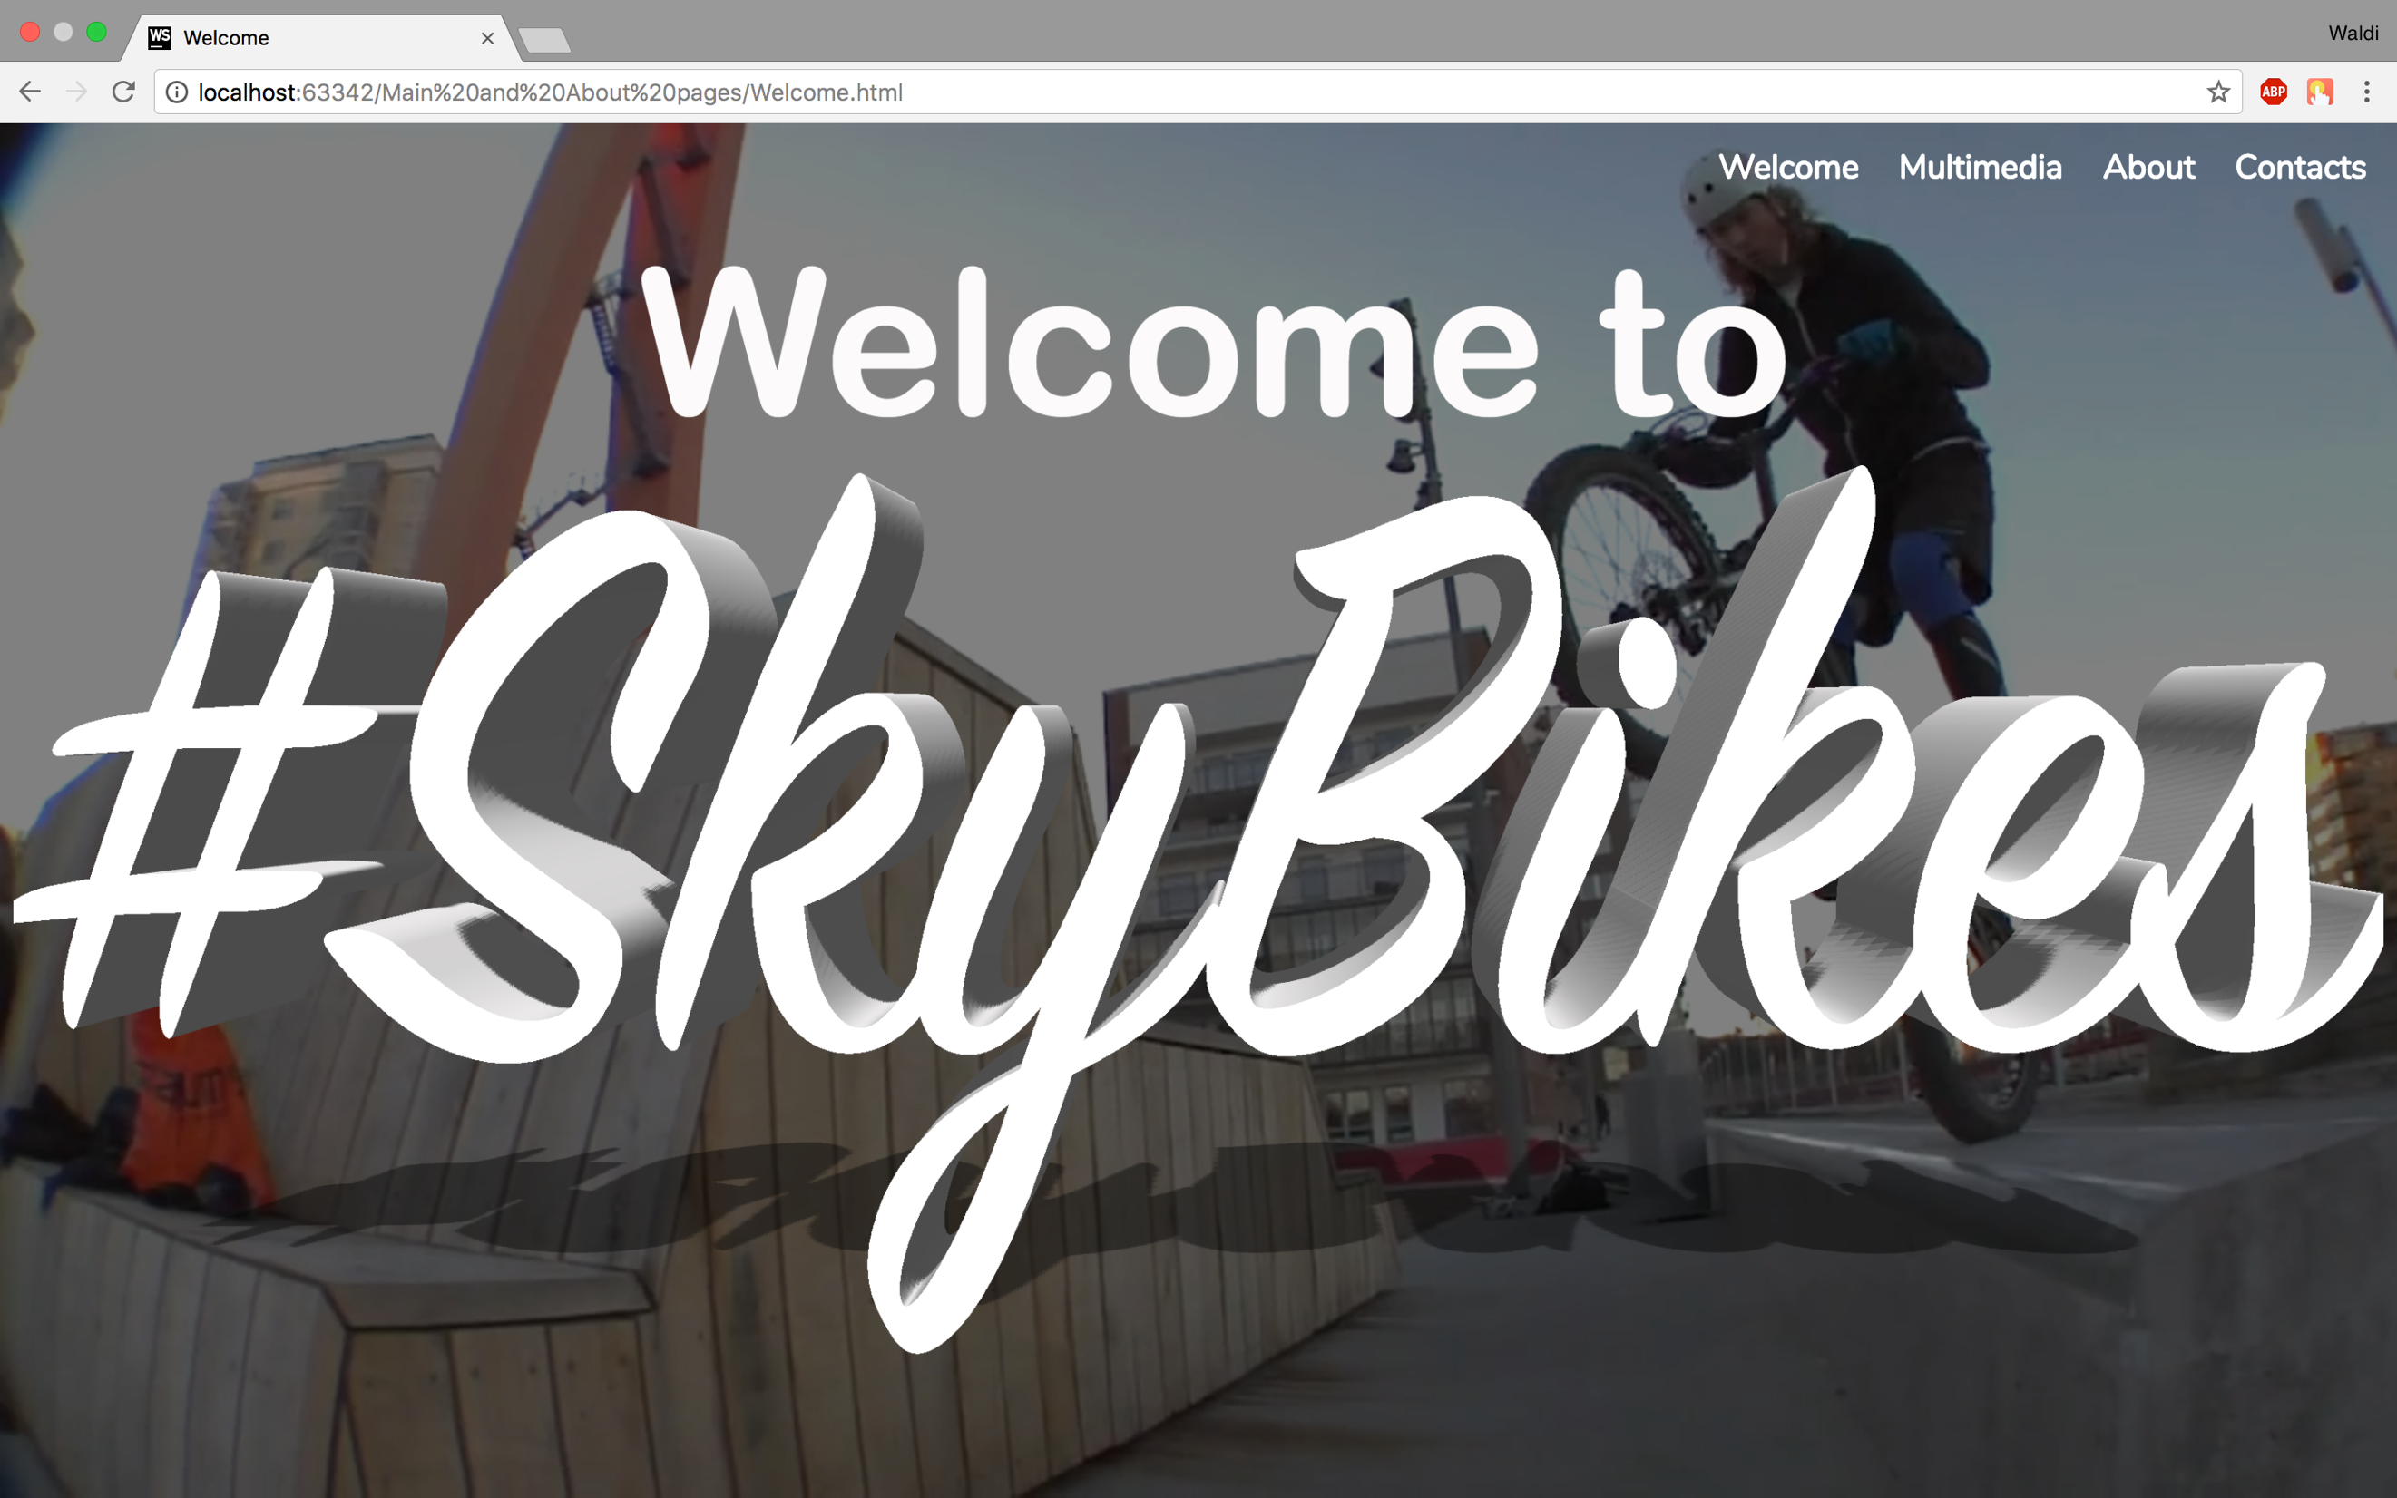

Multimedia page

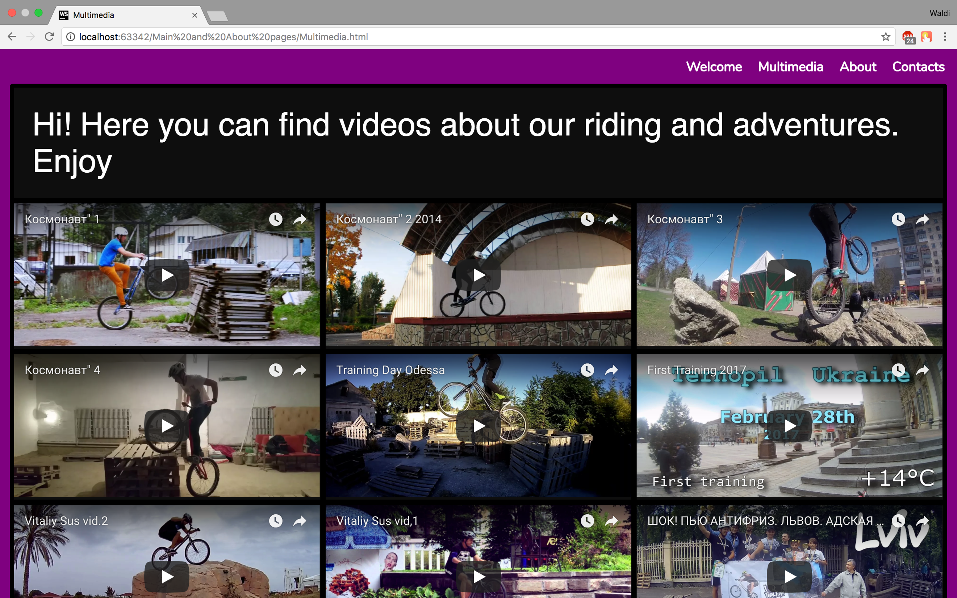

About page

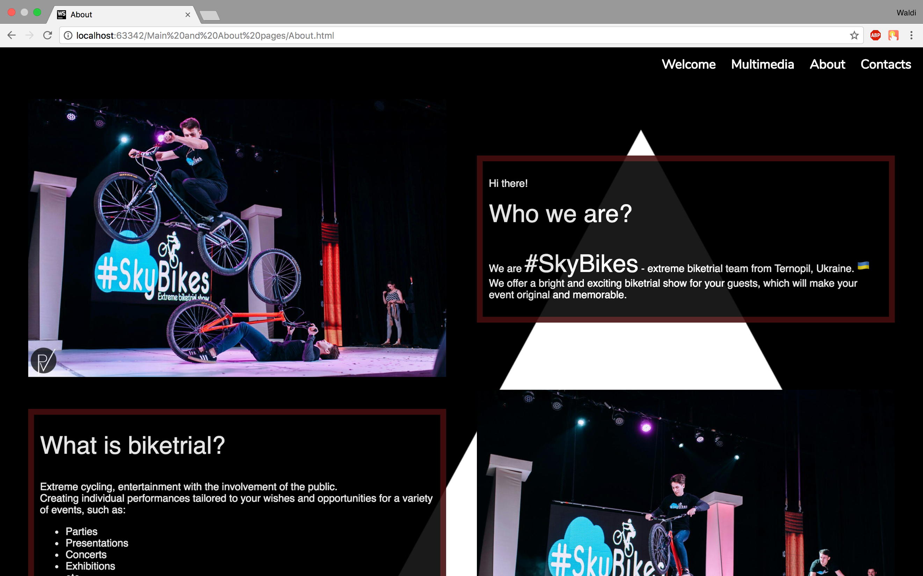

Contacts page

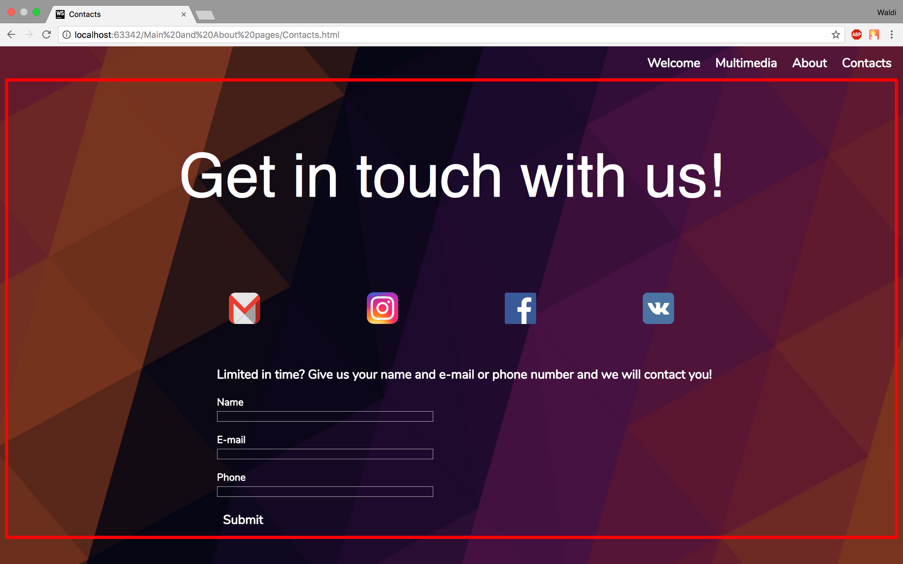

# Documentation (Summary)

1. Welcome page

Design:

The design is pretty simple and clear. The background is the video of biketrial sports. On the top are four buttons for website navigation. Also, there is one transparent picture with text “Welcome to #SkyBikes”. Page contains three separate css files (one for buttons, one for page and one for fonts).

Main features:

The main feature is background video. It placed on three divs to make it full screen and static. The background color of the page is black, and video opacity is 0.5, so the video is not so bright as the original.

2. Multimedia page

Design:

This page has background color purple and contains the same navigation buttons on the top, div with text and other divs with videos from YouTube. The page is pretty simple, and allow the user to watch videos on YouTube and make it fullscreen. Div, which contain divs with video is black for better looking. Page contains three separate css files (one for buttons, one for page and one for fonts).

Main features:

the main feature is video, which is embedded with YouTube standard tool (Copy embed code). Thanks, these videos are placed perfectly on the page. Also, I changed size from default to width="460" height="215" for better looking on my page, which contains 12 videos about #SkyBikes team.

3. About page

Design:

I tried to make the design more interesting on this page. On the top are four buttons for website navigation. This page contains six divs on the lowest level, three of them contain photos and three contain text (description).All of them have the black background with custom opacity and borders with custom color and opacity. They all placed on div with class “about”. This div is transparent, so the user can see background picture (white triangle). The background picture is static, so when user scrolling page, he can see movements of six divs and static background page. Also, contain footer on the right bottom. Page contains three separate css files (one for buttons, one for page and one for fonts).

Main features:

Main features are transparent div which contain six other divs with the black background and custom opacity.

4. Contacts page

Design:

the design is different from all pages. On the top are four buttons for website navigation. The background is the picture with a red border. There are some text and images as links for the Gmail, Instagram, Facebook and VK websites. Pressing these pictures user moves to another site, which listed above. Also, there are three custom inputs for customer information. The user can fill these forms and manager will call or text back to the customer in few hours. Also, there is Submit button with the same style as navigation buttons on the top. Page contains three separate css files (one for buttons, one for page and one for fonts) and one javascript file for validation.

Main features:

There are no something special here except javascript validation of user inputs. It can check if inputs are empty, validate email and phone number. Also, validation shows alert if something wrong. There are four javascript functions: for checking the name, checking email, checking phone number and checking if fields are not empty. First three functions work as onblur, the last one is work when user click “Submit” button. Alerts are the default.

Fonts:

I used two fonts on my website: 'Nunito', sans-serif and "Acuminpro regular", sans-serif with different sizes. I get 'Nunito' from “https://fonts.googleapis.com” and add to my project with the separate link on every page.

Videos:

All videos from Multimedia and the Welcome page is available on YouTube and everyone can use it for any purposes.

Pictures:

I used several images as background and links. Transparent image with text, placed on the Welcome page I did by myself. All other pictures I get from Google images, all of them have free access and everybody can use them for any purposes.

Resources:

Here is list of websites where I get needed information for my web site:

https://www.youtube.com/watch?v=jV8B24rSN5o&t=587s,

https://www.webdesignerdepot.com/2013/04/how-to-create-a-great-about-page/;

https://www.smashingmagazine.com/2009/08/taming-advanced-css-selectors/;

Compatibility:

My website works properly on Chrome, Mozilla, and Safari. Works really bad in Edge and IE. Also, I did all project in WebStorm editor on MacOS with resolution 2560 x 1600. I`m not sure it will be the same on other machines.

# HTML and SCC code

1. Welcome page

HTML

<!DOCTYPE html>

<html lang="en">

<head>

<meta charset="UTF-8">

<title>Welcome</title>

<link rel="stylesheet" type="text/css" href="Welcome.css">

<link rel="stylesheet" type="text/css" href="Buttons.css">

<link href="https://fonts.googleapis.com/css?family=Nunito" rel="stylesheet">

</head>

<body>

<div id="video">

<video id="background_video" autoplay loop>

<source src="background.mp4" type="video/mp4">

</video>

</div>

<div class="background">

<div class="buttons">

<div id="buttons_grid">

<div id="buttons">

<a class="button" href="Welcome.html">Welcome</a>

<a class="button" href="Multimedia.html">Multimedia</a>

<a class="button" href="About.html">About</a>

<a class="button" href="Contacts.html">Contacts</a>

</div>

</div>

<div id="logo">

<img src="SkyBikesLogo.png" style="width: 100%; position: absolute;">

</div>

</div>

</div>

</body>

</html>

CSS

body {

background-color: black;

}

.background {

position: relative;

top: 0;

left: 0;

right: 0;

bottom: 0;

}

#video {

width: 100%;

height: 100%;

position: absolute;

padding: 0;

margin: 0;

left: 0px;

top: 0px;

}

#background_video {

min-height: 100%;

min-width: 100%;

background-color: black;

opacity: 0.5;

position: fixed;

}

#logo {

margin-top: 9%;

}

1. Multimedia

HTML

<!DOCTYPE html>

<html lang="en">

<head>

<meta charset="UTF-8">

<title>Multimedia</title>

<link rel="stylesheet" type="text/css" href="Multimedia.css">

<link rel="stylesheet" type="text/css" href="Buttons.css">

<link href="https://fonts.googleapis.com/css?family=Nunito" rel="stylesheet">

</head>

<body>

<div class="background">

<div class="main">

<div id="buttons_grid">

<div id="buttons">

<a class="button" href="Welcome.html">Welcome</a>

<a class="button" href="Multimedia.html">Multimedia</a>

<a class="button" href="About.html">About</a>

<a class="button" href="Contacts.html">Contacts</a>

</div>

</div>

</div>

<div id="videos">

<div id="text" class="videos">

Hi! Here you can find videos about our riding and adventures. Enjoy

</div>

<div class="videos">

<iframe width="460" height="215" src="https://www.youtube.com/embed/LHK16wIXU6I" frameborder="0"

allowfullscreen></iframe>

</div>

<div class="videos">

<iframe width="460" height="215" src="https://www.youtube.com/embed/ntgy3FYLvG0" frameborder="0"

allowfullscreen></iframe>

</div>

<div class="videos">

<iframe width="460" height="215" src="https://www.youtube.com/embed/Q3xEokjNk1M" frameborder="0"

allowfullscreen></iframe>

</div>

<div class="videos">

<iframe width="460" height="215" src="https://www.youtube.com/embed/FMC0P9-lf5k" frameborder="0"

allowfullscreen></iframe>

</div>

<div class="videos">

<iframe width="460" height="215" src="https://www.youtube.com/embed/v4E56sq4cl0" frameborder="0"

allowfullscreen></iframe>

</div>

<div class="videos">

<iframe width="460" height="215" src="https://www.youtube.com/embed/K4hzSSAkH_w" frameborder="0"

allowfullscreen></iframe>

</div>

<div class="videos">

<iframe width="460" height="215" src="https://www.youtube.com/embed/YY0Xj8gXBx4" frameborder="0"

allowfullscreen></iframe>

</div>

<div class="videos">

<iframe width="460" height="215" src="https://www.youtube.com/embed/uVZTTrYgUuQ" frameborder="0"

allowfullscreen></iframe>

</div>

<div class="videos">

<iframe width="460" height="215" src="https://www.youtube.com/embed/zlX0BVcWOVk" frameborder="0"

allowfullscreen></iframe>

</div>

<div class="videos">

<iframe width="460" height="215" src="https://www.youtube.com/embed/LXe0Zr5XmJA" frameborder="0"

allowfullscreen></iframe>

</div>

<div class="videos">

<iframe width="460" height="215" src="https://www.youtube.com/embed/ud2j7K1GBGQ" frameborder="0"

allowfullscreen></iframe>

</div>

<div class="videos">

<iframe width="460" height="215" src="https://www.youtube.com/embed/edB0L5z-QUo" frameborder="0"

allowfullscreen></iframe>

</div>

</div>

</div>

</body>

</html>

CSS

body {

background-color: purple;

}

.background {

width: auto;

position: static;

top: 0;

left: 0;

right: 0;

bottom: 0;

}

#video {

width: 100%;

height: 100%;

position: absolute;

padding: 0;

margin: 0;

left: 0px;

top: 0px;

}

.main {

display: grid;

}

.videos {

position: relative;

background-color: rgb(15, 15, 15);

}

#videos {

background-color: black;

position: relative;

display: grid;

align-items: center;

grid-template-columns: repeat(3, 1fr);

grid-gap: 0.5em;

padding: 0.4%;

margin: 0.5%;

color: white;

border-radius: 4px;

font-family: "Acuminpro regular", sans-serif;

justify-items: stretch;

}

#text {

justify-self: center;

grid-column: 1/4;

color: white;

font-family: "Acuminpro regular", sans-serif;

padding: 2%;

position: relative;

font-size: 300%;

}

#background_video {

min-height: 100%;

min-width: 100%;

background-color: black;

position: fixed;

}

1. About page

HTML

<!DOCTYPE html>

<html lang="en">

<head>

<meta charset="UTF-8">

<title>About</title>

<link rel="stylesheet" type="text/css" href="About.css">

<link rel="stylesheet" type="text/css" href="Buttons.css">

<link href="https://fonts.googleapis.com/css?family=Nunito" rel="stylesheet">

</head>

<body>

<div id="video">

<img id="background_picture" src="triangle.png">

</div>

<div class="background">

<div class="main">

<div id="buttons_grid">

<div id="buttons">

<a class="button" href="Welcome.html">Welcome</a>

<a class="button" href="Multimedia.html">Multimedia</a>

<a class="button" href="About.html">About</a>

<a class="button" href="Contacts.html">Contacts</a>

</div>

</div>

</div>

<div class="about">

<div>

<img style="width: 100%" src="1.jpg">

</div>

<div class="text">

<p>

Hi there! <br>

<p><span style="font-size: 38px">Who we are?</span></p> <br>

We are <span style="font-size: 38px">#SkyBikes</span> - extreme biketrial team from Ternopil, Ukraine.

<img style="width: 20px" src="flag.png"> <br>

We offer a bright and exciting biketrial show for your guests, which will make your event original and memorable.

<br>

</p>

</div>

<div class="text">

<p>

<p><span style="font-size: 38px">What is biketrial?</span></p> <br>

Extreme cycling, entertainment with the involvement of the public. <br>

Creating individual performances tailored to your wishes and opportunities for a variety of events, such

as: <br>

<ul>

<li>Parties</li>

<li>Presentations</li>

<li>Concerts</li>

<li>Exhibitions</li>

<li>etc</li>

</ul>

We work all over world, individual work with each client. <br>

The numerous participation in various events in Ukraine and abroad will ensure the quality, safety and

good mood of your guests.

</p>

</div>

<div>

<img style="width: 100%" src="2.jpg">

</div>

<div>

<img style="width: 100%" src="3.jpg">

</div>

<div class="text">

<p>

<p><span style="font-size: 38px">What about prices?</span></p> <br>

Our prices are all depends on what you need. Starting from 50$ per one show, together we can create

everything you want. Also, we always ready to offer you some of our stock shows. Please, contact us

to get final prices and conditions.

</p>

</div>

</div>

<div id="footer">#SkyBikes &copy; All rights reserved / 300283178</div>

</div>

</body>

</html>

CSS

body{

background-color: black;

}

.background {

width: auto;

position: static;

top: 0;

left: 0;

right: 0;

bottom: 0;

}

#video {

width: 100%;

height: 100%;

position: absolute;

padding:0;

margin:0;

left: 0px;

top: 0px;

}

.main {

display: grid;

}

.about {

position: relative;

display: grid;

align-items: center;

grid-template-columns: repeat(2, 1fr);

grid-gap: 1em;

grid-column-gap: 3em;

padding: 2%;

margin: 0.5%;

background-color: transparent;

color: white;

border-radius: 4px;

font-family: "Acuminpro regular", sans-serif;

}

#background_picture {

min-height: 100%;

min-width: 100%;

background-color: black;

position: fixed;

}

#links{

display: grid;

grid-template-columns: repeat(6, 1fr) ;

grid-gap: 0.1em;

}

.symbols{

border: 1px solid black;

}

.symbols:hover{

border: 1px solid white;

border-radius: 15px;

}

.text{

position: inherit;

background-color:black;

opacity: 0.9;

padding: 1.5%;

border: 9px solid rgba(140, 26, 26, 0.5);

}

#footer{

color: darkgrey;

margin-left: 77%;

position: relative;

}

1. Contacts page

HTML

<!DOCTYPE html>

<html lang="en">

<head>

<meta charset="UTF-8">

<title>Contacts</title>

<link rel="stylesheet" type="text/css" href="Contacts.css">

<link rel="stylesheet" type="text/css" href="Buttons.css">

<link href="https://fonts.googleapis.com/css?family=Nunito" rel="stylesheet">

<script type="text/javascript" src="Contacts.js"></script>

</head>

<body>

<div id="video">

<img id="background_picture" src="b6.png">

<link rel="stylesheet" type="text/css" href="Buttons.css">

</div>

<div class="background">

<div class="main">

<div id="buttons_grid">

<div id="buttons">

<a class="button" href="Welcome.html">Welcome</a>

<a class="button" href="Multimedia.html">Multimedia</a>

<a class="button" href="About.html">About</a>

<a class="button" href="Contacts.html">Contacts</a>

</div>

</div>

</div>

</div>

<div id="content">

<div id="text" class="content">

<p>Get in touch with us! </p>

<div class="text">

<div id="links">

<div><a href="mailto:rkmnslt@gmail.com"><img class="symbols" id="gmail" src="gmail.png"

style="width: 50px"></a></div>

<div><a href="https://www.instagram.com/vitaliy_sus/"><img class="symbols" id="instagram"

src="instagram.png" style="width: 50px"></a>

</div>

<div><a href="https://www.facebook.com/rkmnslt?ref=bookmarks"><img class="symbols" id="facebook"

src="facebook.png"

style="width: 50px"></a></div>

<div><a href="https://vk.com/skybikes_extremebiketrialshow"><img class="symbols" id="vk" src="vk.svg"

style="width: 50px"></a></div>

</div>

</div>

</div>

<div id="forms" class="content">

<p style="font-size: 20px">Limited in time? Give us your name and e-mail or phone number and we will contact

you!</p>

<p>

Name<br/> <input type="text" class="inputs" id="name" size="56" onblur="return checkName(this.value);"/>

</p>

<p>

E-mail<br/> <input type="text" class="inputs" id="e-mail" size="56"

onblur="return checkEmail(this.value);"/>

</p>

<p> Phone<br/> <input type="text" class="inputs" id="phone" size="56" maxlength="12"

onblur="return checkNumber(this.value);"/>

</p>

<button class="button" onclick="showAlert()">Submit</button>

</div>

</div>

</body>

</html>

CSS

body {

background-color: black;

}

.background {

width: auto;

position: static;

top: 0;

left: 0;

right: 0;

bottom: 0;

}

#video {

width: 100%;

height: 100%;

position: absolute;

padding: 0;

margin: 0;

left: 0px;

top: 0px;

opacity: 0.5;

}

.main {

display: grid;

}

#video {

width: 100%;

height: 100%;

position: absolute;

padding: 0;

margin: 0;

left: 0px;

top: 0px;

}

#background_picture {

height: 100%;

width: 100%;

background-color: black;

position: fixed;

}

.content {

position: relative;

background-color: transparent;

padding: 0.5%;

margin: auto;

}

#content {

background-color: transparent;

position: relative;

display: grid;

align-items: center;

grid-template-columns: repeat(1, 1fr);

grid-gap: 0.5em;

color: white;

border-radius: 4px;

font-family: "Acuminpro regular", sans-serif;

justify-items: stretch;

border: 5px solid red;

margin-top: 0.4%;

}

#text {

padding-top: 0%;

grid-column: 1/3;

font-size: 600%;

background-color: transparent;

color: white;

}

#links {

display: grid;

grid-template-columns: repeat(4, 1fr);

grid-gap: 0.1em;

justify-items: center;

align-items: center;

}

.symbols {

border: 3px solid transparent;

}

.symbols:hover {

border: 3px solid white;

border-radius: 15px;

}

.text {

position: inherit;

background-color: transparent;

}

#forms {

color: white;

font-family: 'Nunito', sans-serif;

font-weight: bold;

padding-left: 4%;

margin-bottom: 0%;

}

.inputs {

background-color: transparent;

border: 1px solid rgba(255, 255, 255, 0.5);

color: white;

}

CSS for buttons (every page)

#buttons {

position: relative;

}

#buttons_grid {

justify-self: end;

grid-column: 1/5;

}

.buttons {

display: grid;

grid-template-columns: repeat(4, 1fr);

grid-gap: 0.5em;

justify-items: start;

}

.button {

font-family: 'Nunito', sans-serif;

font-weight: bold;

display: inline-block;

padding: 5px 10px;

font-size: 20px;

cursor: pointer;

text-align: center;

text-decoration: none;

outline: none;

color: #fff;

background-color: transparent;

-webkit-user-select: none;

border: none;

border-radius: 4px;

}

.button:hover {

background-color: black;

box-shadow: 3px 3px white;

transform: translate(0px, 0px);

}

.button:active {

background-color: transparent;

box-shadow: 1px 1px white;

transform: translate(2px, 2px);

}

Javascript for validation (Contacts page)

function checkNumber(fieldValue) {

var numberCheck = isNaN(fieldValue);

if (numberCheck == true) {

window.alert("Enter the valid number please");

return false;

}

else {

return true;

}

}

function checkEmail(fieldValue) {

if (/^\w+([\.-]?\w+)*@\w+([\.-]?\w+)*(\.\w{2,3})+$/.test(fieldValue)) {

return true;

}

else {

alert("Enter the valid e-mail address please");

return false;

}

}

function checkName(fieldValue) {

var nameCheck = fieldValue;

if (nameCheck == "") {

window.alert("Enter name please");

return false;

}

else {

return true;

}

}

function showAlert() {

if (document.getElementById("name").value !== "") {

if (document.getElementById("e-mail").value || document.getElementById("phone").value !== "") {

alert("Thank you for your interest to our team! We will contact with you in few hours");

document.getElementById("name").value = "";

document.getElementById("e-mail").value = "";

document.getElementById("phone").value = "";

}

else {

alert("Enter e-mail address or phone number please")

}

}

else {

alert("Enter the name and e-mail or phone number please")

}

}